**DART EXPRESS LOGISTICS**

**PROBLEM STATEMENT:**

|  |  |
| --- | --- |
| Name of the Industry | Travel/Logistics |
| Problem Statement | GPS based Tracking Application with Logistics Management. |
| Challenge  description with context | In today's era time to time product delivery is very important for any transport organization. Also, if the product is organic then product freshness is also important. To target this, we develop new system which can provide real-time location of product and user (transport owner) can control sensor to maintain product freshness. |
| Exact Problem | Our system is a GPS tracking system in which we track the truck which is supplied by supplier. Our system provides real-time asset tracking. In our system we have instant alerts on mobile SMS or Email to the truck driver to warn the driver when there is some emergency or any defect in the truck freezer. In this system we have required three hardware devices for tracking and measure the temperature of truck:  1. GPS module. 2. GSM module, 3. Temperature Sensor. |
| Users | 1. Admin, 2. Supplier, 3. Truck Driver. |
| Expected Outcomes | That's Why We Develop Website for Track and Maintain Freshness of Products. |

# Notice:

# Our Problem statement demands the use of GSM module, GPS modules and temperature sensors, which we do not have access to. On receiving instructions from our reporting manager, we implemented the tasks by using random values.

# Overall Description

The following section presents an overall description of the subject Logistics industry. In particular, the product has been put into perspective through a detailed assessment of the hardware, software requirements

# Hardware Requirements

For developing the application, the following are the hardware requirements

GPS tracker, Temperature Not available.

# Software Requirements

1. **Spring Tool Suite**
2. **Java**
3. **JavaScript**
4. **HTML**
5. **CSS**
6. **JSP**
7. **BOOTSTRAP**
8. **H2 Database**
9. **Maven**

**10.Tomcat server**

1. **API of third-party service not available for GSM and SMTP mail.**

# Typical customers: Our platform was designed primarily for a pre-existing logistic company(B2B).

# Platforms supported

* Web

# Support options

* 24/7 (Live rep)
* Knowledge Base
* Email/Help Desk

# Functional and Non-Functional Requirements

The following section presents the complete set of functional and non- functional requirements identified for the subject Logistics industry. Functional requirements are listed first, according to their relationship to the overall system, customers, Supplier, delivery. The non-functional requirements that pertain to safety, security, the interface, human engineering, qualification, operation, maintenance and performance are subsequently presented.

# Actors

There are Three actors in this Logistics Industry

* + Admin
  + Supplier
  + Delivery person/truck driver

# Functional Requirements

This subsection presents the identified functional requirements for the subject Logistics industry. Initially, general requirements that pertain to the whole system are given. Where possible, subsequent requirements have been demarcated based on their relevance to the users of the system, that is, Admin, deliver partnefr/truck driver , Supplier.

# Admin

Table presents the identified functional Admin requirements that directly relate to the customers of the subject Logistics industry.

|  |  |
| --- | --- |
| **Requirement** | **Description** |
| 01 | There is only one admin, who has access to monitor and view all Supplier/Delivery partner details and also details of all orders. |
| 02 | Admin can approve/reject a newly registered supplier or a delivery partner. |
| 03 | Admin can place a new order. |
| **04** | **Admin can assign a particular supplier/truck driver to complete any order.** |
| **05** | **Admin will have the live temperature of the parcel, as well as live tracking facility.** |
| **06** | **Admin can alert the truck driver incase there is any fluctuations(ideally the optimum temperature required to keep the parcel in prime condition) in the temperature of the parcel** |

**Functional Admin Requirement**

# Supplier

Table presents the identified functional requirements of a Supplier.

|  |  |
| --- | --- |
| **Requirement** | **Description** |
| 01 | Supplier can choose the supplier profile in the home page, where he will be directed to the supplier login page. A new supplier can register on the register page, whose account will only be active after being approved by the admin. |
| 02 | After logging in the supplier will be able to monitor order details and also details of truck drivers associated with each orders. |

## Delivery partner/Truck driver

Table presents the identified functional requirements of a truck driver.

|  |  |
| --- | --- |
| **Requirement** | **Description** |
| 01 | Truck driver can choose the supplier profile in the home page, where he will be directed to the supplier login page. A new supplier can register on the register page, whose account will only be active after being approved by the admin. |
| 02 | Truck driver After logging in will be able to monitor order details and also details of the parcel and suppliers such as pick-up and drop locations. |
| 03 | Truck driver will receive alerts from admin incase of any temperature fluctuations. |

**Table 3.1.4 Functional Chef Requirements**

# Use case descriptions

Table presents the Log In use case description to show the interaction of Actors when logging into the system.

|  |  |
| --- | --- |
| **Use Case** | Log In |
| **Primary Actor** | Admin, Supplier and Truck Driver |
| **Goal In Context** | Enable Actors access to the system through a app |
| **Preconditions** | The Actors has a valid username and password and is not already logged in |
| **Scenario** | 1. The Actors selects ‘Log In’ from the app menu 2. The app prompts the user for their username and password 3. The Actors enters their username and password 4. The app enables access to the system according to access control |
| **Exceptions** | The Actors enters an invalid username or password |

**Table : Log In Use Case Description**

Table presents the Log Out use case description to show the interaction between a Admin and a Navbar when logging out of the system.

|  |  |
| --- | --- |
| **Use Case** | Log Out |
| **Primary Actor** | Admin, Supplier and Truck Driver |
| **Goal In Context** | Disable Actors access to the system through a app |
| **Preconditions** | The actors is already logged in |
| **Scenario** | 1. The actors selects ‘Log Out’ from the Navbar 2. The Navbar disables access to the system |

**Table: Log Out Use Case Description**

Table presents the Place Order use case description to show the interaction between a customer and a surface computer when placing an order.

|  |  |
| --- | --- |
| **Use Case** | Place Order |
| **Primary Actor** | Admin |
| **Goal In Context** | Place an order for menu items from the Admin |
| **Preconditions** | The admin has been set up the applications |
| **Trigger** | The admin wants to place the order |
| **Scenario** | 1. The Admin selects 'New Order' from the menu and can able to make the new orders |

**Table : Place Order Use Case Description**

Table presents the View Details use case description to show the interaction between a Actors and a surface computer when viewing orders.

|  |  |
| --- | --- |
| **Use Case** | View Order/Track orders |
| **Primary Actor** | Admin, Supplier, Truck drivers |
| **Goal In Context** | Place an order for menu items from the Admin |
| **Preconditions** | The actors has been set up the applications |
| **Trigger** | The actors should view order details which includes (Pick-up, drop, supplier details, Truck driver details, Temperature details) |
| **Scenario** | 1. The Admin selects 'New Order' from the menu and can able to make the new orders. |

Main Home Page with cards to choose role among 3 options.

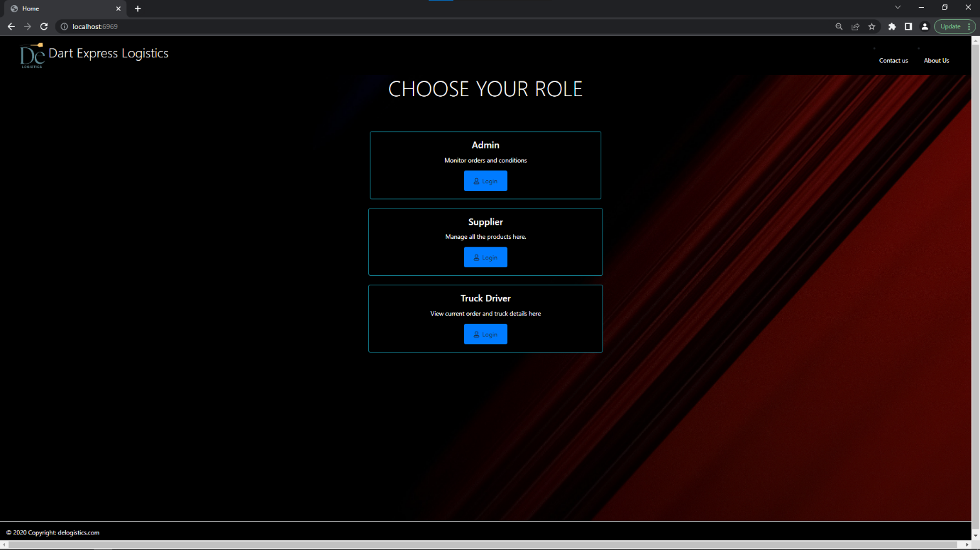

About us page including information about Individual roles.

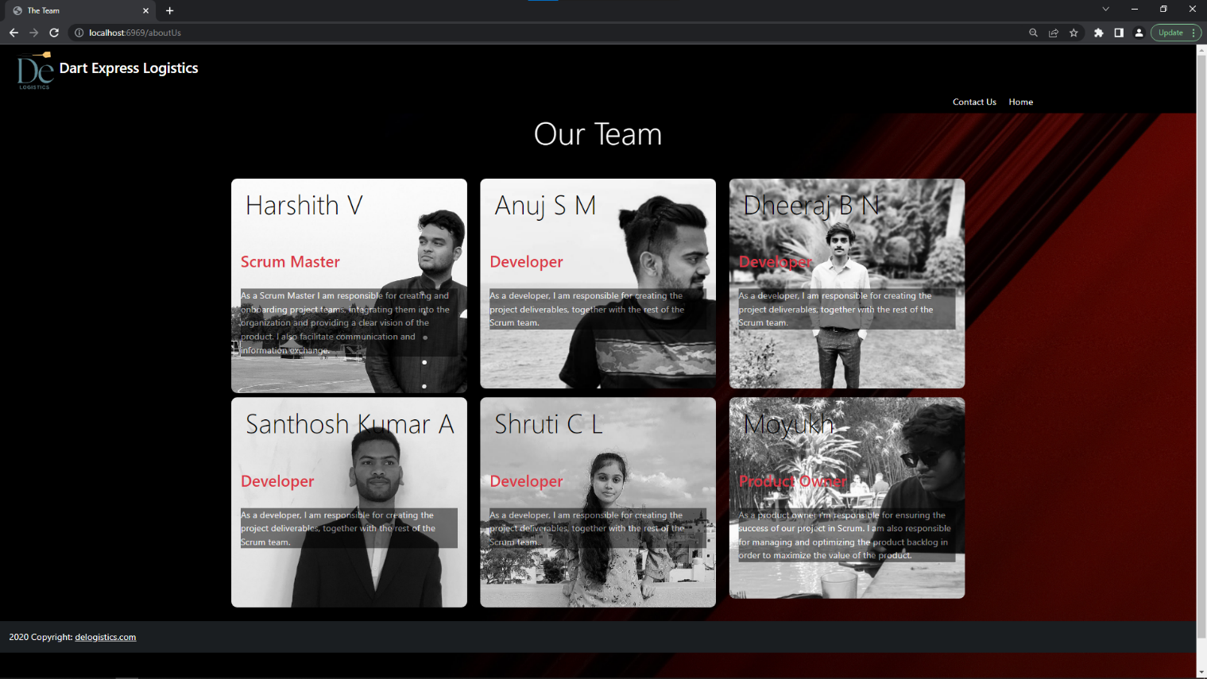

Contact us page with contact information.

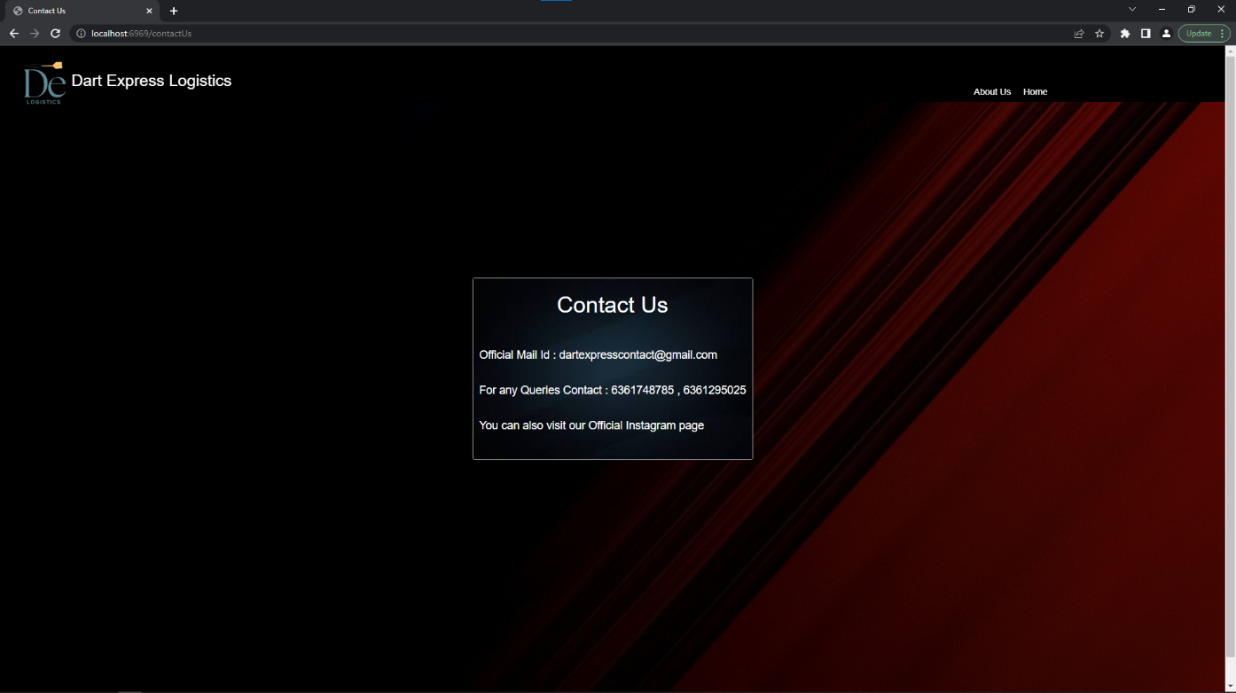

Admin Login Page

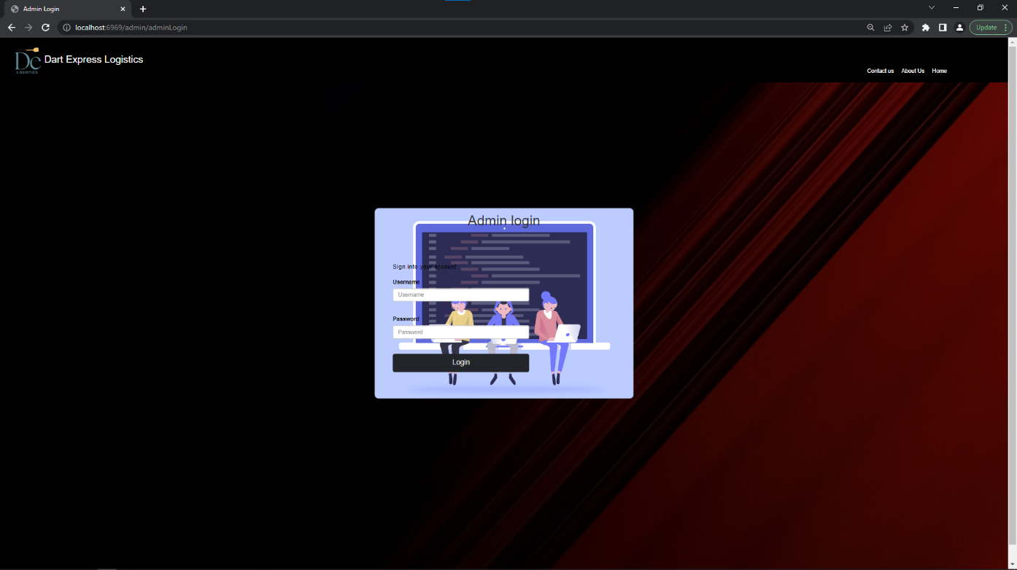

Admin Home page- Navigate through buttons with various functionalities

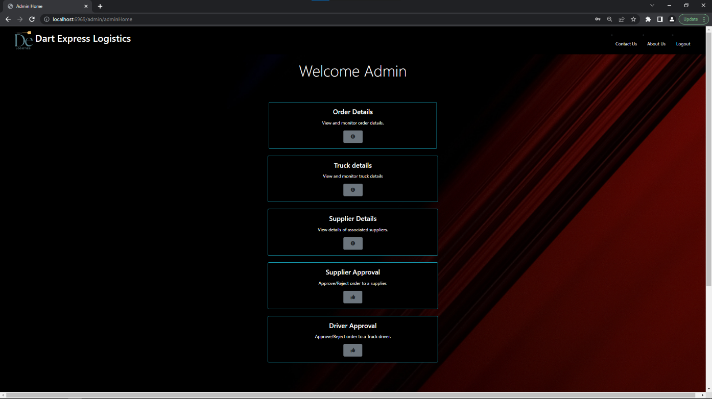

Order details page to view all orders and a button to create new order

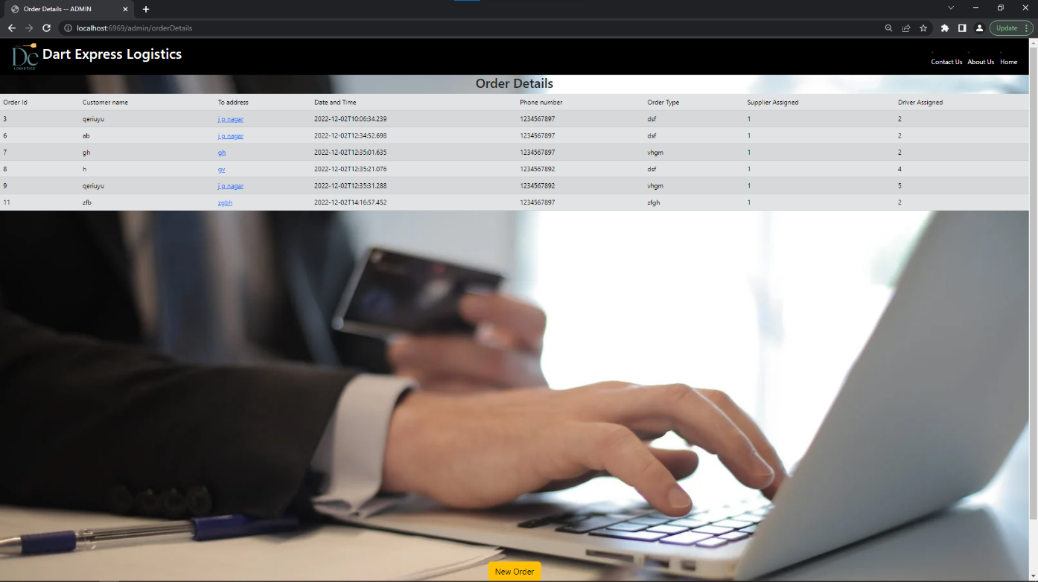

*delivery address can be viewed on google maps with just a click

Supplier details page to view all supplier information

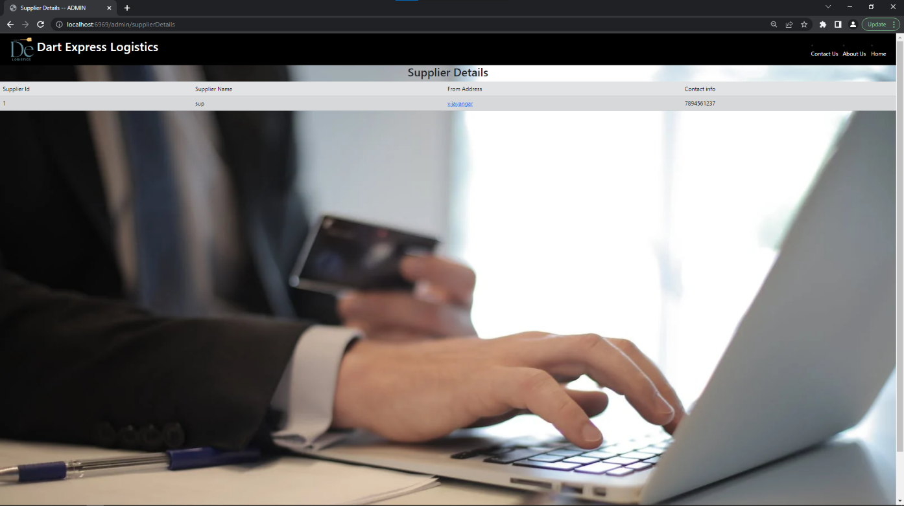

*delivery address can be viewed on google maps with just a click

Truck details page to view all driver information

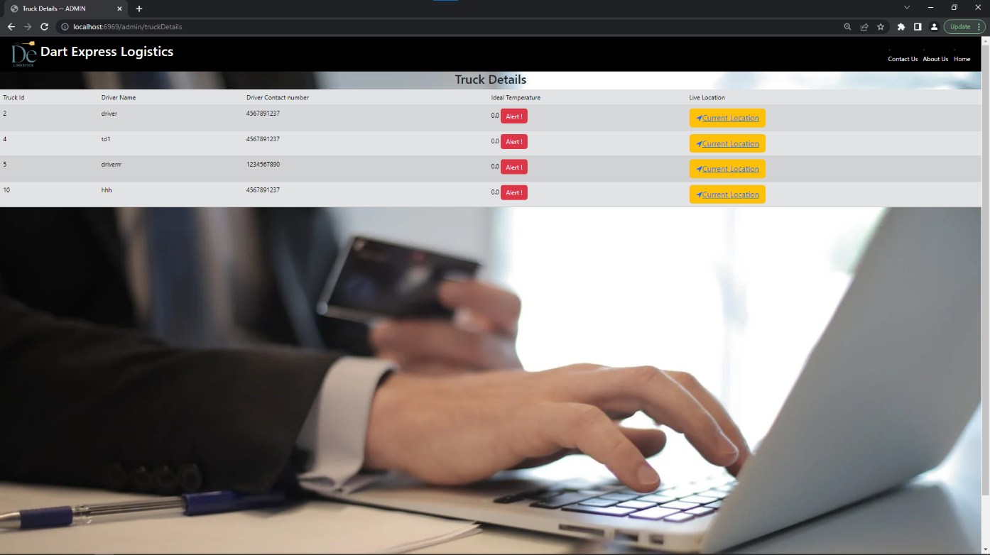

*truck’s live location can be viewed on google maps with just a click

**Alert button sends a mail and SMS to the truck driver

Pending supplier information can be viewed and accepted/rejected here

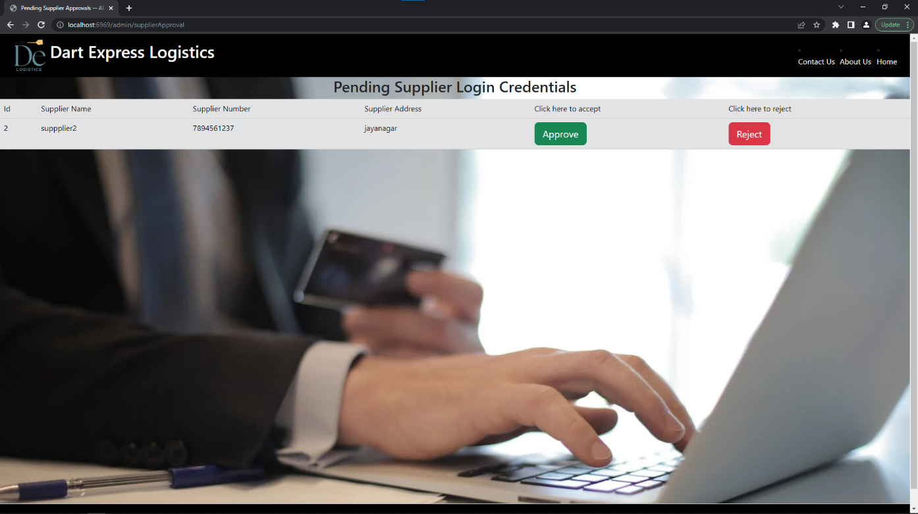

Pending supplier information can be viewed and accepted/rejected here

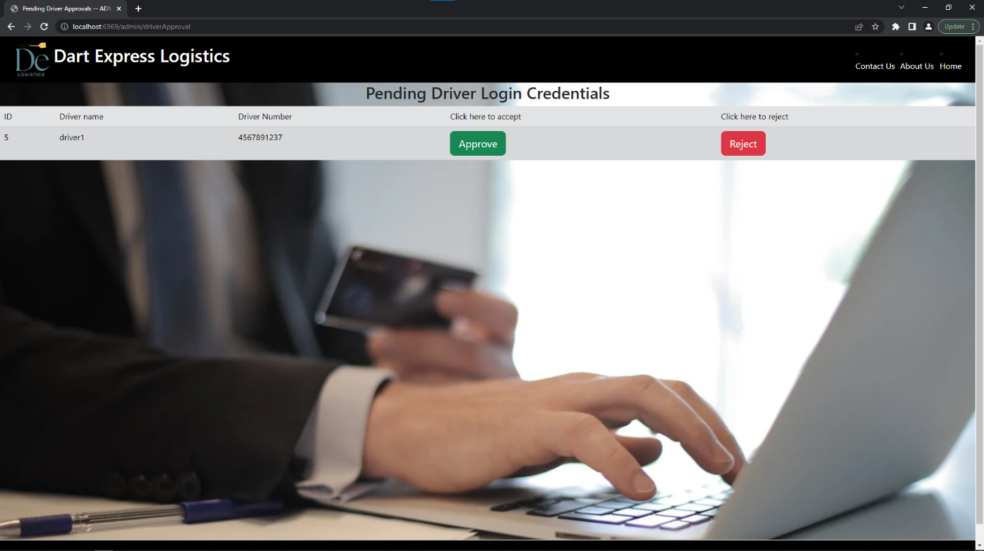

Supplier login page

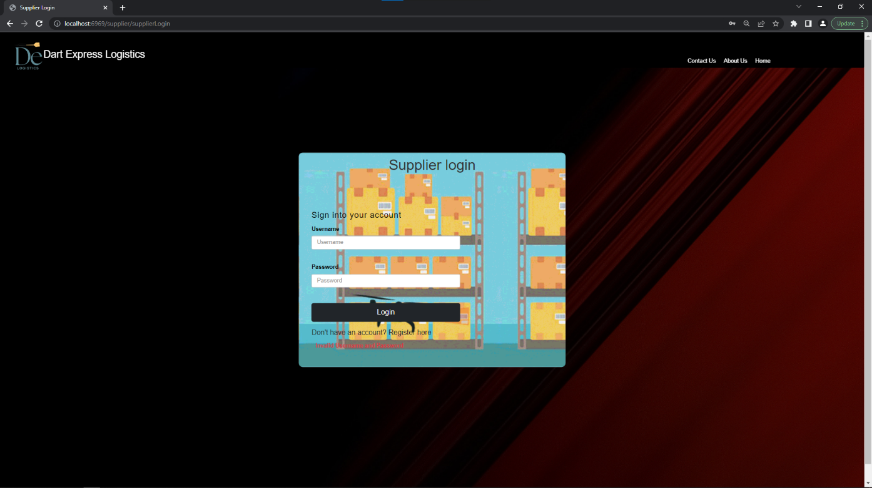

Supplier Registration page

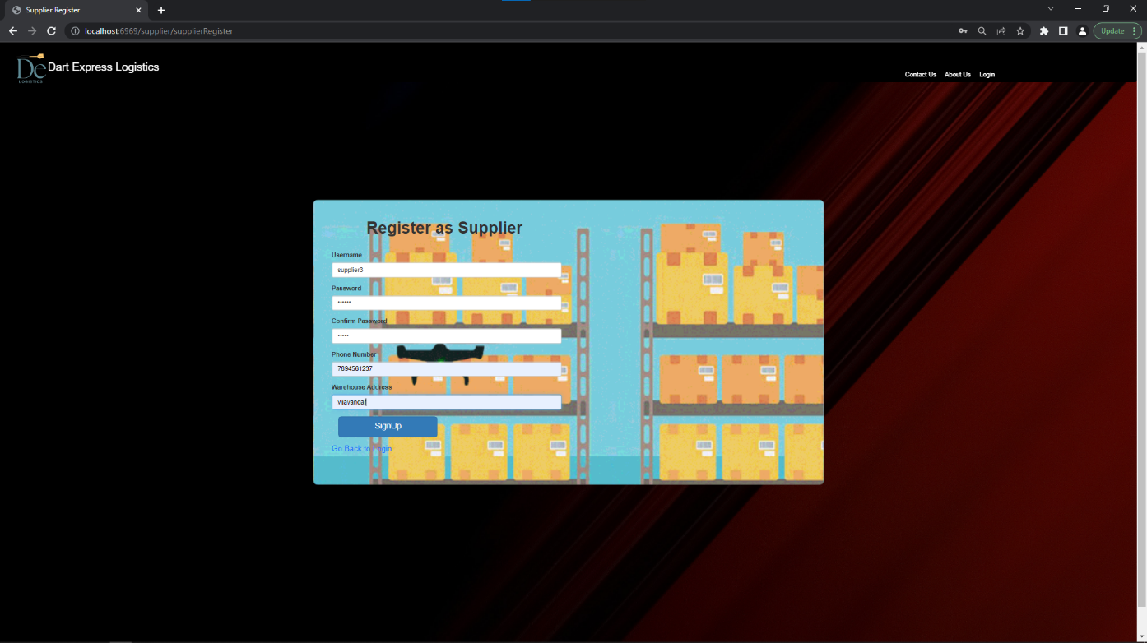

Supplier Homepage

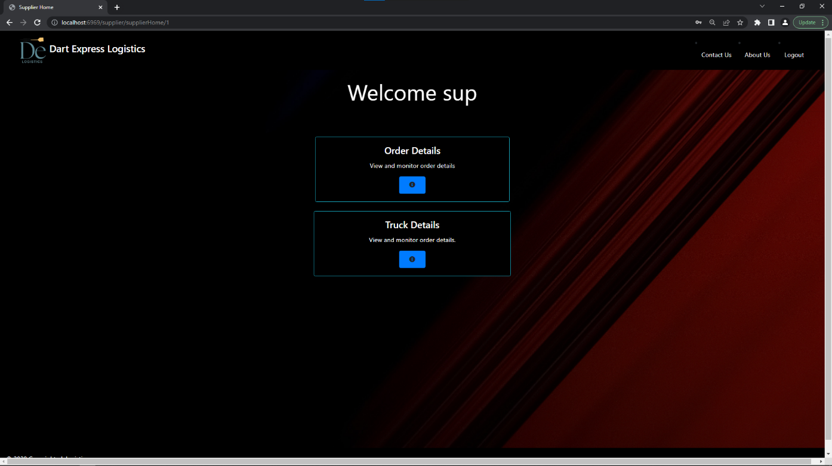

Order details of all orders related to that particular supplier

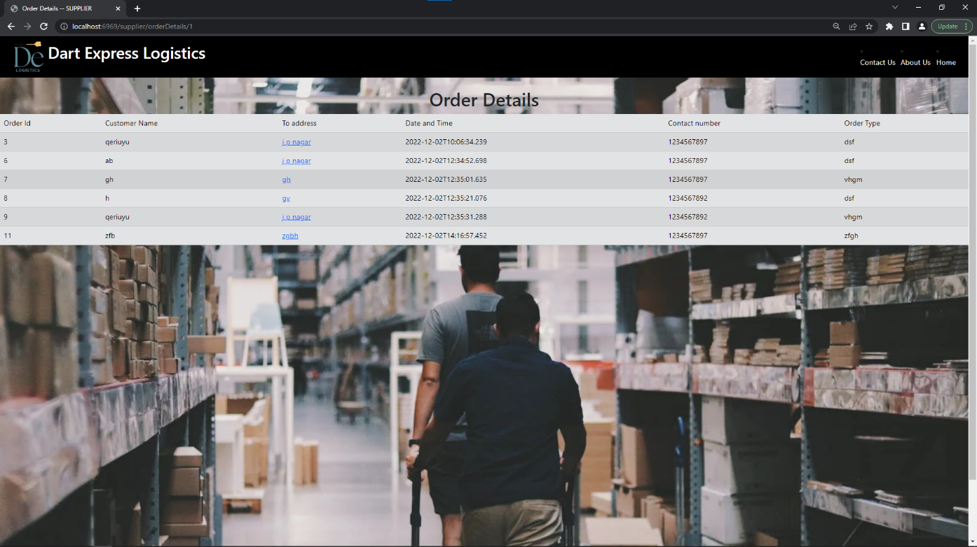

Truck details of all drivers assigned to that particular supplier

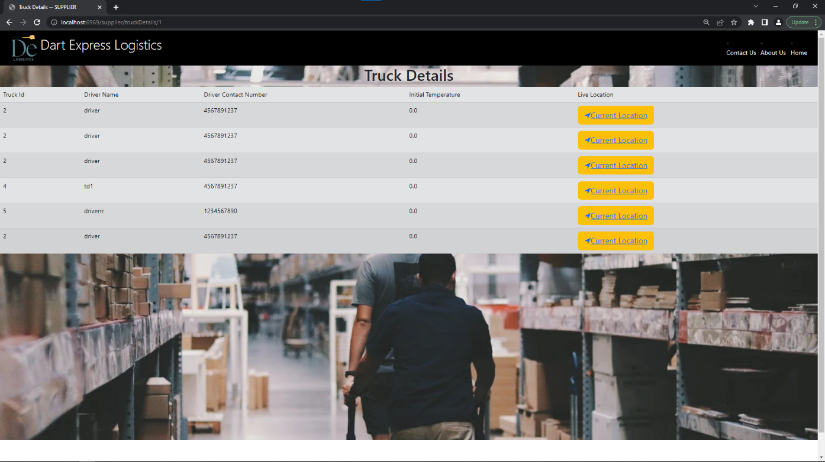

Driver login page

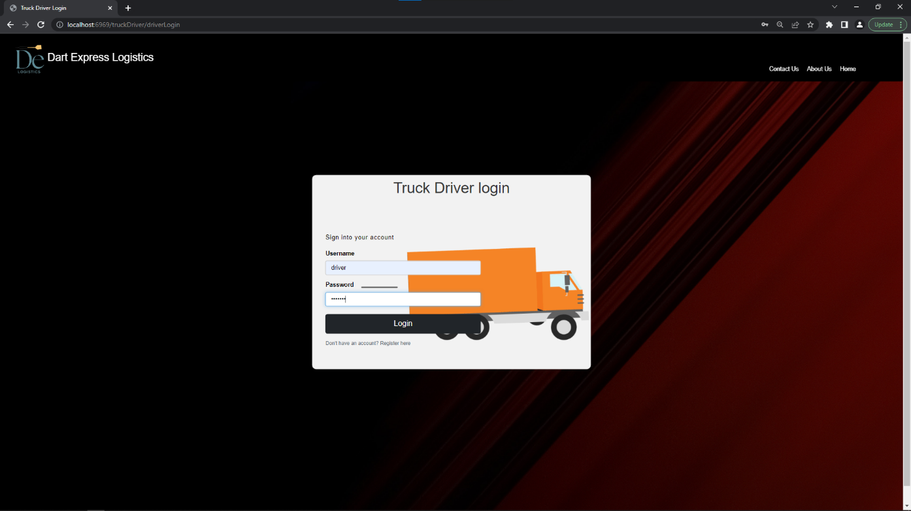

Driver Registration page

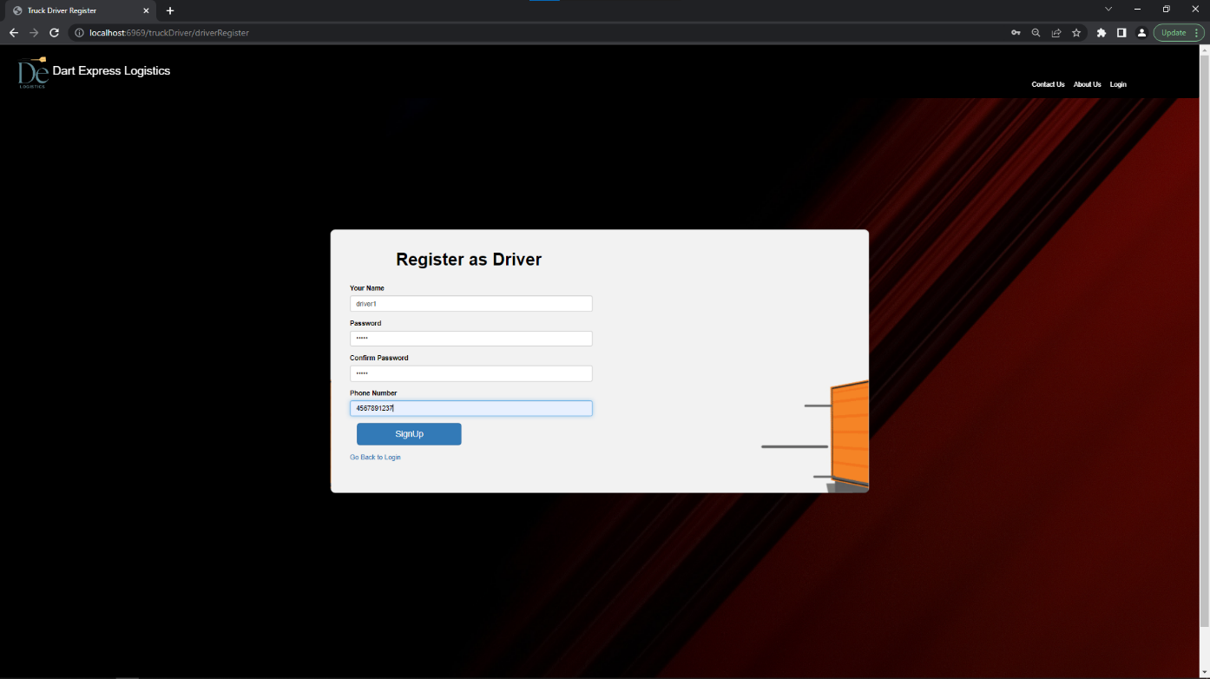

Truck Driver home page

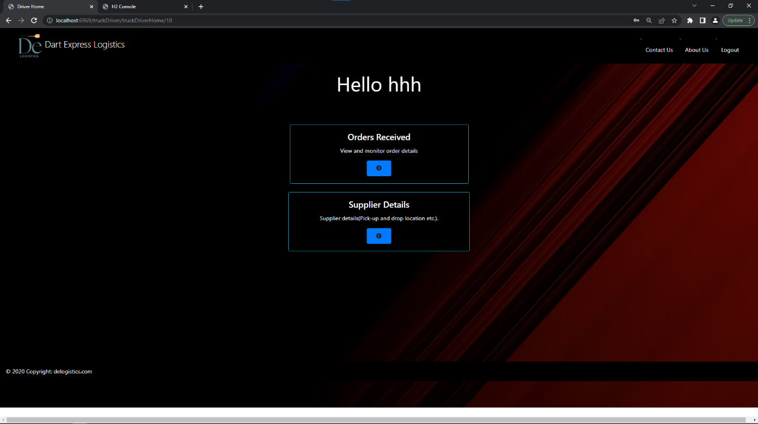

Order details of all orders assigned to that particular driver

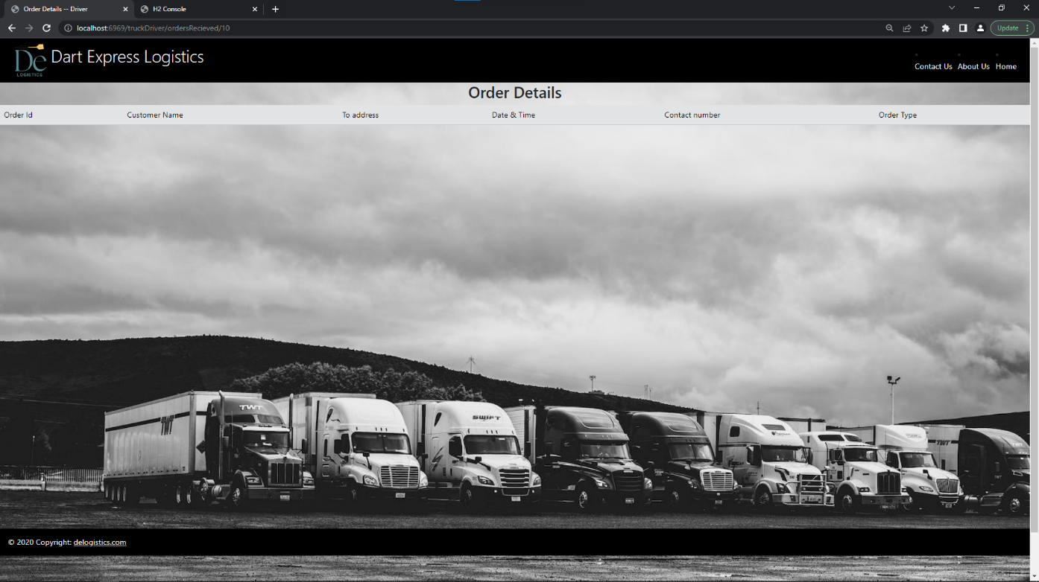

Supplier details of all suppliers related to that particular driver

